Parametric Model: Logistic Regression for Machine Failure Prediction
Abhinav M
Fy M.sc Statistics – Data Science

Logistic Regression
In statistics, a logistic model (or logit model) is a statistical model that models the log-odds of an event as a linear combination of one or more independent variables.In regression analysis, logistic regression estimates the parameters of a logistic model (the coefficients in the linear or non linear combinations). In binary logistic regression there is a single binary dependent variable, coded by an indicator variable, where the two values are labeled "0" and "1", while the independent variables can each be a binary variable (two classes, coded by an indicator variable) or a continuous variable (any real value). The corresponding probability of the value labeled "1" can vary between 0 (certainly the value "0") and 1 (certainly the value "1"), hence the labeling.[1]
Logistic regression is frequently used in predictive maintenance to model whether a machine is in a normal operating state (0) or a failure state (1). Logistic regression forecasts the likelihood that an observation falls into a specific class, as opposed to linear regression, which forecasts a continuous numerical value. After that, a predetermined decision threshold—typically 0.5—is used to translate this probability into a class label. Logistic regression establishes a relationship between a set of independent variables (features) and the probability of the target event using the logistic (sigmoid) function.
To predict thequalitative response or classify the output variable in distinct categories, logistic regressionis considered. It determines the probability of belonging to a particular category. Linearand logistic regression are based on the linearity assumption. In situations when data arenonlinear, these models provide poor predictive performance[4]

The model can be expressed as:
$$P(Y=1∣X)=\frac{1}{1+e^{-(β_{0}+β_{1}X_{1}+β_{2}X_{2}+⋯+β_{p}X_{p})}}$$
where:
- $Y$is the binary target variable (machine failure),
- $X_{1},X_{2},…,X_{p}$are input features (e.g., temperature, torque, speed),
- $β_{0}$is the intercept,
- $β_{1},β_{2},…,β_{p}$are model coefficients.
The sigmoid function ensures that the predicted values lie between 0 and 1, making them interpretable as probabilities.

The Benefits of Logistic Regression for Predictive Maintenance
The following factors have led to the successful application of logistic regression in numerous machine failure prediction studies:
1. Interpretability
Each coefficient directly indicates how strongly a variable increases or decreases failure probability. This transparency is crucial in industrial environments, where maintenance engineers require explainable decisions rather than black-box predictions [2]
2. Probabilistic Result
LR offers a failure probability rather than a strict binary outcome, allowing threshold-based decisions (e.g., preventive maintenance when failure probability exceeds 0.7).
3. Robustness with Appropriate Feature Design
Despite being a linear classifier, previous research demonstrates that, when paired with carefully thought-out features and suitable class weighting for unbalanced data, logistic regression can accurately model complex machine behavior.

Definition of Target Variable & Explanatory Variables In The Study
The target variable in this investigation is described as:
- {Target = 1} :- There was a machine failure
- {Target = 0 }: -The machine is functioning normally

This definition aligns with established predictive maintenance literature, where machine failure is treated as a rare event, often resulting in class imbalance [2].
Failure cases make up a small portion of all observations in the dataset used for this project, which is an expected and realistic feature of industrial failure data.
This project's dataset includes a variety of operational and sensor-based features. Based on their significance to machine deterioration and failure mechanisms, the following explanatory variables were chosen for the Logistic Regression model:
Temperature of the Air [K] : Represents the machine's surrounding ambient temperature. Higher air temperatures have the potential to accelerate component wear and increase thermal stress.
Temperature of Process [K] : How’s the machine's internal operating temperature while it is being processed. Overheating and a higher chance of failure are frequently linked to high process temperatures.
Speed of Rotation [rpm] : determines how quickly machine parts rotate. Mechanical fatigue and imbalance can be caused by extremely high or variable rotational speeds.
Torque (Nm) : Represents the machine's mechanical load. Increased stress on mechanical parts is indicated by higher torque values, which may result in early failure.
Tool Wear [min] : Shows the total amount of time the tool has been used. Tool wear is a crucial sign of deterioration and is frequently connected to manufacturing system failure events.

Handling Class Imbalance
Machine failure data are inherently imbalanced, as failures occur far less frequently than normal operation. Prior studies demonstrate that ignoring class imbalance leads to misleading accuracy results and poor failure detection performance [3].
To address this issue:
- Class weighting was applied during model training.
- Evaluation emphasized recall, F1-score, and ROC-AUC, rather than accuracy alone.
This approach follows best practices outlined in recent predictive maintenance research[3].
Correlation Analysis of Explanatory Variables
To determine the direction and strength of relationships between explanatory variables and the target variable, correlation analysis is used.
The linear relationship between numerical variables in this study was assessed using the Pearson correlation coefficient. A perfect positive linear relationship is indicated by a Pearson correlation coefficient of +1, which falls between –1 and +1. A perfect negative linear relationship is indicated by -1. No linear relationship is indicated by 0. To make interpretation easier, a correlation matrix was created and displayed using a heatmap.
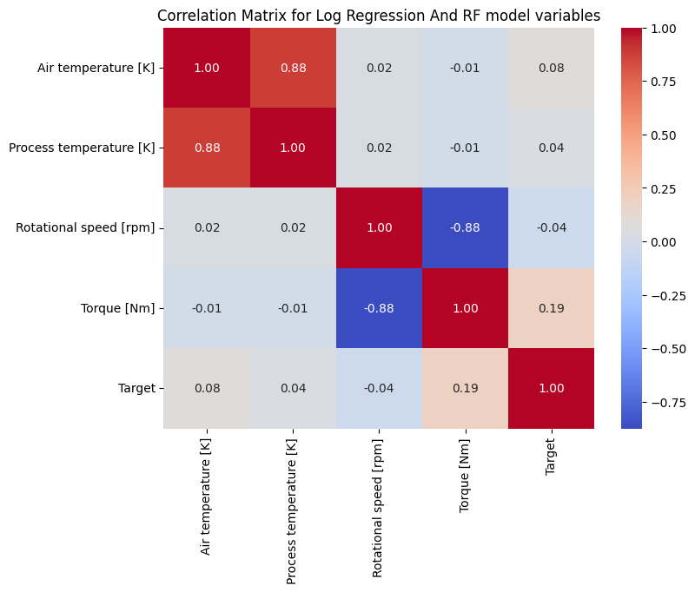
Key findings from the correlation analysis were as follows:
- There was a strong positive correlation between process temperature and air temperature, suggesting that higher internal machine temperatures are linked to rising ambient temperatures.
- A weak to moderate negative correlation was found between torque and rotational speed, indicating that lower rotational speeds frequently result in higher torque demands.
- Tool wear showed a moderate correlation with torque and temperature variables, underscoring its function as a machine degradation indicator.
- Relatively little direct correlation was found between the target variable (machine failure) and individual predictors, indicating that a combination of factors rather than a single variable influences failure events.

Training and Assessment of Models
Operational and sensor-based features were used to train the logistic regression model. On a held-out test set, performance was assessed using:
- Train-Test Split
- Confusion Matrix
- Precision, Recall, and F1-score
- ROC-AUC score
Strong discrimination ability between failure and non-failure states is indicated by the obtained ROC-AUC score of 0.9079892826695896, which is in line with findings from comparable industrial studies. [2]
The model achieved high recall, which means it successfully identified the majority of failure events—a crucial requirement in safety-critical systems—despite having moderate precision for the failure class.
Train-Test Split:
- Ten thousand observations make up the dataset, which has a binary target variable that indicates machine failure.
- To maintain class distribution, a stratified split was used to separate the data into training and testing sets.

- 8,000 samples in the training set:
-> No Failure (0): 7,729
->Failure (1): 271
- 2,000 samples in the testing set:
-> No Failure (0): 1,932
->Failure (1):68
The models were constructed using the training set, and their predictive performance on untested data was assessed using the testing set.

Confusion Matrix:
[[1584 348]
[ 11 57]]
Classification Report:
 | Precision | recall | f1-score | support
0 | 0.99 | 0.82 | 0.90 | 1932
1 | 0.14 | 0.84 | 0.24 | 68

accuracy |  |  | 0.82 | 2000
macro avg | 0.57 | 0.83 | 0.57 | 2000
weighted avg | 0.96 | 0.82 | 0.88 | 2000

Confusion Matrix Values
Outcome | Meaning | Count
TN | Correctly predicted no-failure | 1584
FP | False alarms | 348
FN | Missed failures | 11
TP | Correctly detected failures | 57

Actual vs Predicted Plot
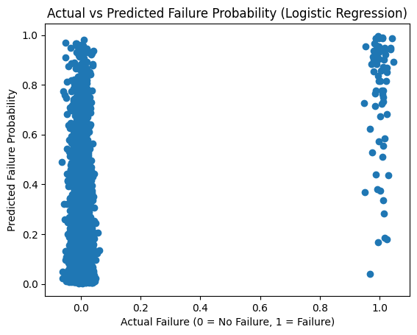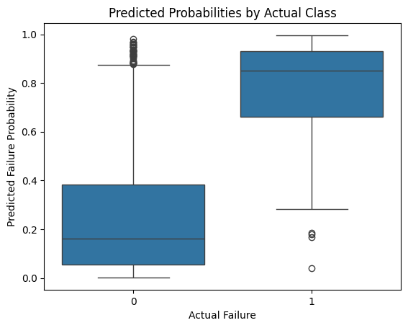
- The Logistic Regression model's ability to predict machine failure is visually assessed using the Actual vs. Predicted scatter plot. The y-axis shows the model's predicted probability of failure, while the x-axis shows the actual machine condition (0 for no failure and 1 for failure).
- Every point represents a distinct observation. Correctly predicted non-failure cases are represented by points near (0, 0), and correctly predicted failure cases are represented by points near (1, 1). Misclassified cases show up as either low predicted probability despite actual failure (false negatives) or high predicted probability but no actual failure (false positives).
- This plot demonstrates the model's efficacy as a parametric baseline model for predictive maintenance and sheds light on how confidently it predicts machine failures.
Conclusion
This study applied reliability-centered predictive maintenance using Logistic Regression and Random Forest models for machine failure prediction. Logistic Regression served as a parametric baseline model, providing interpretable failure probability estimates and supporting informed maintenance decisions [5].
. To address the limitations of linear modeling, a Random Forest classifier was employed, achieving superior predictive performance by capturing non-linear relationships among operational variables, consistent with prior research [4]. The results demonstrate that combining interpretable parametric models with robust non-parametric techniques offers an effective approach for industrial predictive maintenance.
References:
[1] Hosmer, David W.; Lemeshow, Stanley (2000). Applied Logistic Regression (2nd ed.). Wiley. ISBN 978-0-471-35632-5.
[2] Battifarano, M., DeSmet, D., Madabhushi, A., & Nabar, P. (n.d.). Predicting future machine failure from machine state using logistic regression. Department of Civil and Environmental Engineering, Carnegie Mellon University.
[3] Yang, Y., & Wang, H. (n.d.). Random forest-based machine failure prediction: A performance comparison.
[4] Imam, F., Musilek, P., & Reformat, M. Z. (n.d.). Parametric and nonparametric machine learning techniques for increasing power system reliability: A review.
[5] Koppula, M. (n.d.). Predictive maintenance to reduce machine downtime in factories using machine learning algorithms. Department of Computer and Data Science, The University of Texas at Austin, Austin, TX, United States.

